SIMBA

General Board Meeting

Date: 9-12-23

Sabino High School Marching Band

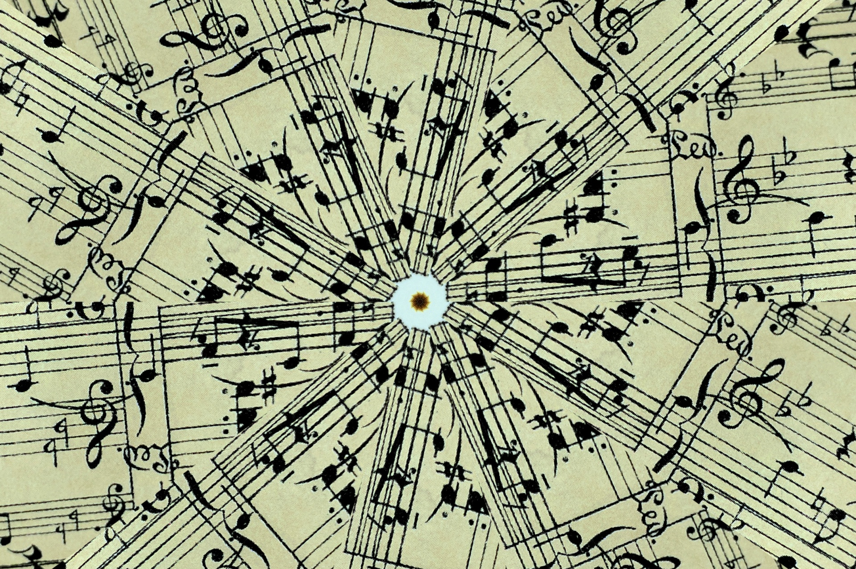

General Board Meeting

9-12-23

SIMBA



Secretary:

Facilitator:

Type of Meeting:

Timekeeper:

Location:

Time:

Meeting called by:

Date:

6:10 p.m. – 7:15 p.m.

In person/Zoom

Shoshana Elkin - President

Shoshana Elkin - President

Shoshana Elkin - President

Jenny Warren

Mr. Taylor, Shoshana Elkin, Jenny Warren, Ashley Smith, Terrence Freeman, Patricia Ballesteros, Amy Rustand, Bridgette Gomez-Munoz

Attendees:

**\*Big need -** Push pit crew to push props- 5-6 props\ 1-2 extra to assemble props, total 10-12 parents, students can help, send home a push pit note and Terrence will send out a communication reminder, push pit crew get in for free admission **\*Show -** Everything ordered for show, vinyl props - got check, ready end of week or next week, prop/push days scheduled to teach parents **\*Fundraising -** A $700 budget from winter remains, add $400 for subwoofers - need brass mutes which cost $400, a total of $800 is needed to purchase subwoofers and brass mutes - $800 was proposed by Ashley Smith to purchase subwoofers and brass mutes for the band, The band will be getting new subwoofers and brass mutes **\*Fee Payment Reminder -** Pay band fees through Zelle\ tax credit **\*Show Shirts –** Tom Carle – shipping costs **\*September 22nd marching band rehearsal marathon -** 1:00 PM -6:30 PM (8:30 PM) - Dinner will be provided for students (SIMBA) **\*September 23 -** Car wash fundraiser\ tickets coming soon\ good with supplies\ sell water X slash sell candy bars from Costco\ Terrence - parent volunteers **\*Amy Rustand –** Parent/sibling band shirts – Proline Graphics (local), ‘Keep the Music Playing’ with Sabercat on front, heather purple in color, 50 adult shirts @ $15 each and 20 kid-size shirts @ $10-$12 each, pre order and pay through Zelle **\*September 29 – Middle School Night -** Invite middle schoolers from all over the district (poster sent to all middle schools), sit with band and play pep tunes, check in will be from 5:00 to 6:00pm, pizza will be served at check in, warm up, march to field, need an assistant to check students in with parent contact information **\*September 30 -** Casa Grande competition , bus leaves from school at 10 AM, students can leave with parents to get to Homecoming Dance (September 30), Mr. Taylor will stay behind for band critiques **\*October 3 -** Fall Concert Band/Orchestra Performance at Sabino, 6:00pm, sell chocolates **\*Mountain March -** November 4th, 8 - 9 schools, evening competition, concessions only, hospitality and judges eat from concessions, set up sitting area for hospitality, mountain March shirts- simple symbol (Amy), Jim click Ford car raffle, Terry will not be doing buttons, marines- yes (Ashley Smith will call) **\*October topics -** Disneyland trip,schedule payments, fundraiser parent group to fundraise through givebutter.com, Bingo in Spring for Spring Trip Fundraiser **\*October 28 – Mountain March next meeting –** parent training/volunteer time TBA

III. Treasurer’s Report –Amy Rustand Checking $3,161.32 Savings $1,661.00

*Savings Account -

IV. Mr. Taylor’s report:

**\*\*Next SIMBA meeting: Monday, October 2nd @ 5:30pm @ Sabino Band Room\*\***

VI. Open Forum/VI. Schedule next meeting and Adjourn

V. Fundraising- included in Director’s Report

*included in Director’s Report/discussion

II. Director’s Report – Mr. Taylor

1. Call to order (time)– 6:10 p.m.

**AGENDA ITEMS**