SIMBA

General Board Meeting

Date: 10-2-23

Sabino High School Marching Band

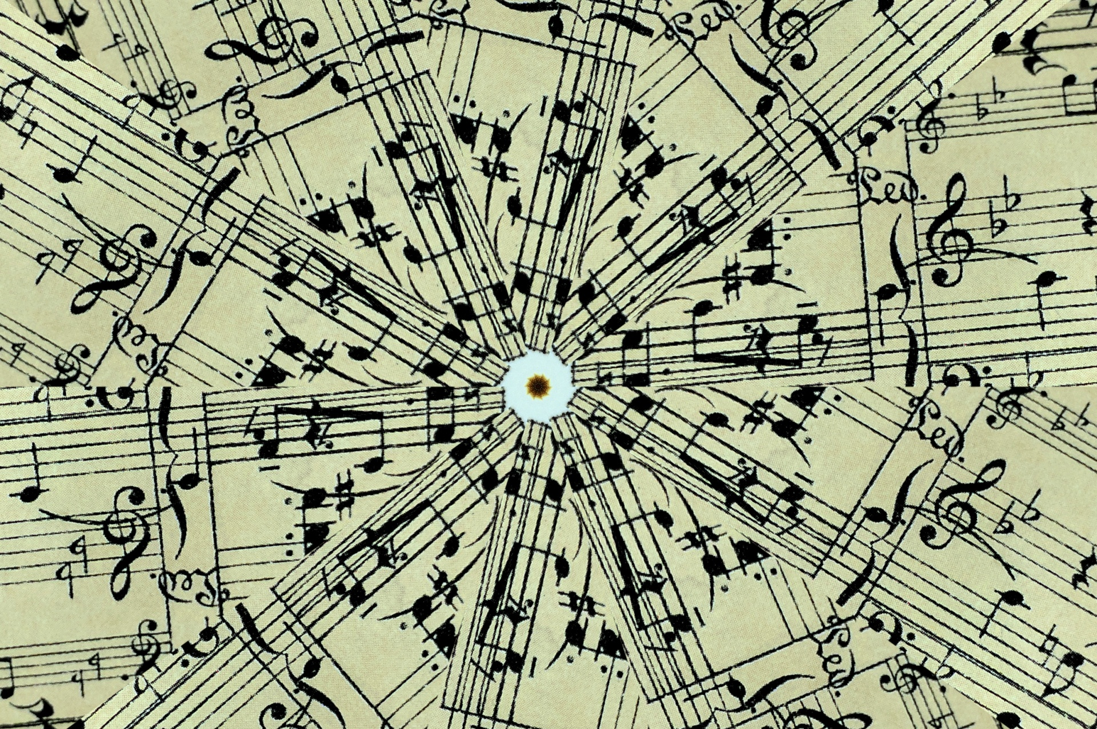

General Board Meeting

10-2-23

SIMBA



Secretary:

Facilitator:

Type of Meeting:

Timekeeper:

Location:

Time:

Meeting called by:

Date:

5:40 p.m. – 6:33p.m.

In person/Zoom

Shoshana Elkin - President

Shoshana Elkin - President

Shoshana Elkin - President

Jenny Warren

Mr. Taylor, Shoshana Elkin, Jenny Warren, Tina Killeen, Ashley Smith, Holly Wright, Mark Munoz

Attendees:

III. Treasurer’s Report –Amy Rustand Checking $4,600 Savings $1,600 car wash brought in $1,000

*Savings Account -

**\*October 3 -** Fall Concert Band/Orchestra Performance at Sabino, dinner at 5:00 for students El Molinito (51 students and Mr. Taylor) show at 6:00pm. **\*Mountain March -** November 4th, 9 schools, evening competition, concessions only, hospitality and judges eat from concessions, set up sitting area for hospitality, mountain March shirts- simple symbol (Amy), Jim click Ford car raffle, Terry will not be doing buttons, Marines- yes (Ashley Smith will call), no shades set up, snacks for judges/hospitality/bus drivers/food on field for judges/one serving table and a bunch of sitting tables/catered food flavored egg rolls/coolers with soda and water/hot chocolate/lighting for barricade order (Mr. Taylor will call)/insurance is done/bus driver packets with meal tickets/Mr. Taylor will get signs on a tripod/order 2 golf carts (Shoshana)/pre order form for schools to order food - hamburgers, hot dogs, nachos/super nachos, pickles, soda (Mr. Taylor will send to schools), glow sticks in school colors, make signs for – concessions, parking, First Aide, Shoshana ordering trophies/have Sabino Football Players/Key Club/NHS students to participate **\*October topics -** Disneyland trip,schedule payments, fundraiser parent group to fundraise through givebutter.com, Bingo in Spring for Spring Trip Fundraiser **\*October 28 – Mountain March next meeting –** parent training/volunteer time TBA **\*Concessions Band Night** – October 29, 2023 – hamburgers, hot dogs, nachos/super nachos, pickles, soda **\*Disneyland Spring Trip** – 1st payment of money collection for trip is Nov. 30, Mr. Taylor will send home information about payment plan this week before Fall Break **\*Bingo Night at 49er Country Club** – November 13, 6:15-6:30 check-in and games begin at 7:00pm **\*December Bake Sale** – at Winter Concert/hot chocolate and cookies served outside after concert **\*October 30th meeting** (for November meeting) – finishing touches for Mountain March/discuss Bingo Night at 49er Country Club

**\*\*Next SIMBA meeting: Monday October 30th (for November’s meeting) @ 5:30pm @ Sabino Band Room\*\***

IV. Mr. Taylor’s report:

VI. Open Forum/VI. Schedule next meeting and Adjourn

V. Fundraising- included in Director’s Report

*included in Director’s Report/discussion

II. Director’s Report – Mr. Taylor

1. Call to order 5:40p.m.

**AGENDA ITEMS**