SIMBA

General Board Meeting

Date: 10-30-23

Sabino High School Marching Band

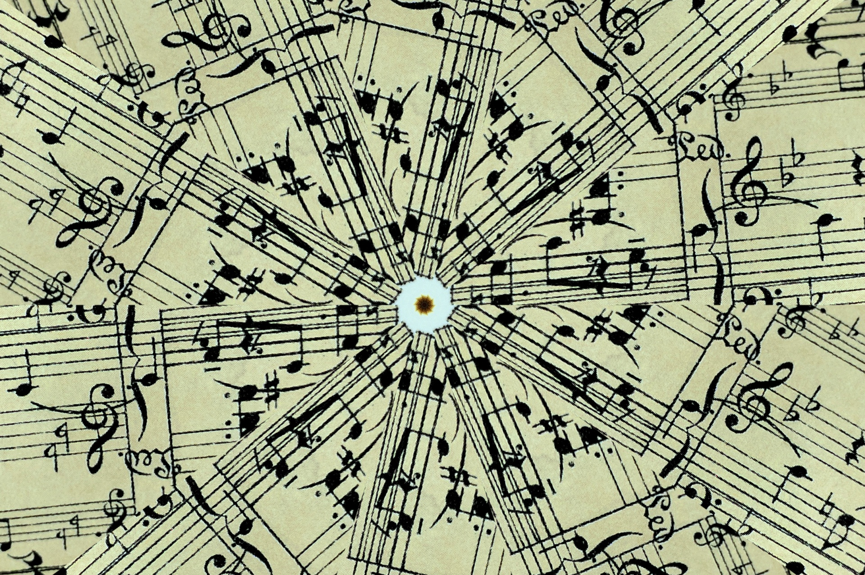

General Board Meeting

10-30-23

SIMBA



Secretary:

Facilitator:

Type of Meeting:

Timekeeper:

Location:

Time:

Meeting called by:

Date:

5:40p.m. – 6:30 p.m.

In person/Zoom

Shoshana Elkin - President

Shoshana Elkin - President

Shoshana Elkin - President

Jenny Warren

Mr. Taylor, Shoshana Elkin, Jenny Warren, Tina Killeen, Ashley Smith, Mark Munoz, Catie Rowden, Amy Rustand, Darin

Attendees:

1. Call to order 5:40 p.m.

II. Director’s Report – Mr. Taylor

* **Nov. 2nd Football Championship Playoff Game** – SIMBA doing concessions, need volunteers to help, need propane tanks filled
* **Mountain March Nov. 3** – 4:00-9:30pm 1st band warm up at 5:27pm, golf carts booked (2), barricades done, lights provided by Mr. Crandall (Mr. Taylor will get in touch with him), Mr. Taylor will assemble signs, awards are done, volunteer needs – how to communicate and fill needs – sign up genius to sign up for volunteer spots, StuCo volunteers to attend to do Air Gram runners/floaters/serve food outside to Directors
* **Mountain March Nov. 3** - 10:00am volunteers needed for clean-up/general meeting in Band Room (set up signs/walk route and train together) wear Sabino attire for all volunteers, working grill – Evan, Chris?, tables – 12 talbles (judges served inside at 5:30 with 3 tables, 12 tables indeed for all areas, all tables are on sight), feeding 30 judges/directors from El Molinito, drinks – 35 pack of coke, sprite, Dr Pepper, Diet Coke, pack of water, lunch for volunteers – Papa John’s pizza, concessions for dinner for band students (mark hand once fed at 5:20 pm to be fed (47 students)/bus drivers, Terrance needs to put out a **HUGE reach out for VOLUNTEERS**! Band route – Mr. Taylor will ask Crandall family to be in charge of route, a parent needed to rope off area (Catie Rowden), set up hot chocolate by stands, tickets are $8
* **Nov. 13 49er Bingo Fundraiser** – Amy Rustand will create Flyer and text it to Jenny Warren to send out to Casey at 49er Country Club

**\*Disneyland Spring Trip** – not discussed at this meeting **\*Bingo Night at 49er Country Club** – November 13, 6:15-6:30 check-in and games begin at 7:00pm **\*December 12th Winter Band Concert Bake Sale** – at Winter Concert/hot chocolate and cookies served outside after concert, table of 3 people to give out winning baked goods

IV. Mr. Taylor’s report:

III. Treasurer’s Report –Amy Rustand Checking $3,702.60 Savings $1,661.21 Concessions for 10/27/23 brought in $1,828.88

*Savings Account -

**\*\*Next SIMBA meeting: Monday, December 4 @ 5:30pm @ Sabino Band Room\*\***

VI. Open Forum/VI. Schedule next meeting and Adjourn

V. Fundraising- included in Director’s Report

**AGENDA ITEMS**