SIMBA

General Board Meeting

Date: 12-4-23

Sabino High School Marching Band

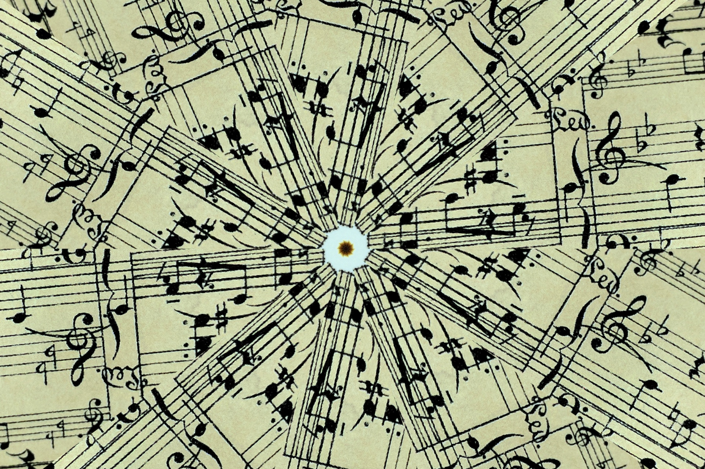

General Board Meeting

12-4-23

SIMBA



Secretary:

Facilitator:

Type of Meeting:

Timekeeper:

Location:

Time:

Meeting called by:

Date:

5:30p.m. – 6:20 p.m.

Zoom only

Shoshana Elkin - President

Shoshana Elkin - President

Shoshana Elkin - President

Jenny Warren

Mr. Taylor, Shoshana Elkin, Jenny Warren, Amy Rustand, Patricia Ballesteros, Terrence Freeman, Holly Wright

Attendees:

**\*Winter 2024 Budget Proposed** – Instructor pay with incentive to be there, design – new floor want/more than need but would like a more generic floor, percussion show paid for, Drill to get written by Tom, props $500 each group, by pre-made sets of uniforms for winter guard/percussion, guard flags, percussion/guard equipment, show shirts, road meals, trailer gas, WGI registration, first aid gear, staff polos/jackets = $22,625/student pays $350 winter percussion fee and fundraise for outstanding &10,000 to cover season fees. Winter Percussion 22 students/Winter Guard 12 students. Approve minutes: Amy Rustand motioned /motion approved by Patricia...Winter 2024 Budget approved.

**\*Spring Semester** – contest music, jazz music pep music

**\*Fundraiser wish list** – new mixer, new trailer

**\*End of year** – uniform dry cleaning/awards

**\*Spring Disney Trip** – do givebutter fundraiser through Booster Club, $950 cost of trip per student, subtract what was fundraised from givebutter per student, cost of trip would be $750-$800 per student, every student can pay entire trip with Tax Credit. 50 students showing interest in attending, givebutter fundraiser starting soon, full one-time payment of Spring Disney Trip due January 30, 2024 **\*December 12th Winter Band Concert Bake Sale @ 6:00pm** – at Winter Concert/hot chocolate (Patricia) and cookies served outside after concert for donation, 5 tables to showcase baked goods, need parents to sign up to bring a dessert, bring desserts by 5:30pm, anyone who wants to bake small bags of cookies to sell for $1 or $2 a bag is greatly appreciated!!! **\*Winter Band Camp needs** – maybe just snacks **\*Spring Bingo Fundraiser** – Jenny Warren will get in touch with Casey at 49er Country Club to set up date soon **\*Co-Chairs Next Year** – thoughts to guide new incoming parents on how SIMBA/Marching Band/Winter Band works, Feb./Mar. look for prospective parents

III. Treasurer’s Report –Amy Rustand Checking $5,394.02 Savings $1,661.21

*Savings Account -

1. Call to order 5:30 p.m.

II. Director’s Report – Mr. Taylor

IV. Mr. Taylor’s report:

**\*\*Next SIMBA meeting: Monday, January 9th @ 5:30pm @ Sabino Band Room\*\***

VI. Open Forum/VI. Schedule next meeting and Adjourn

V. Fundraising- included in Director’s Report

**AGENDA ITEMS**