SIMBA

General Board Meeting

Date: 1-9-24

Sabino High School Marching Band

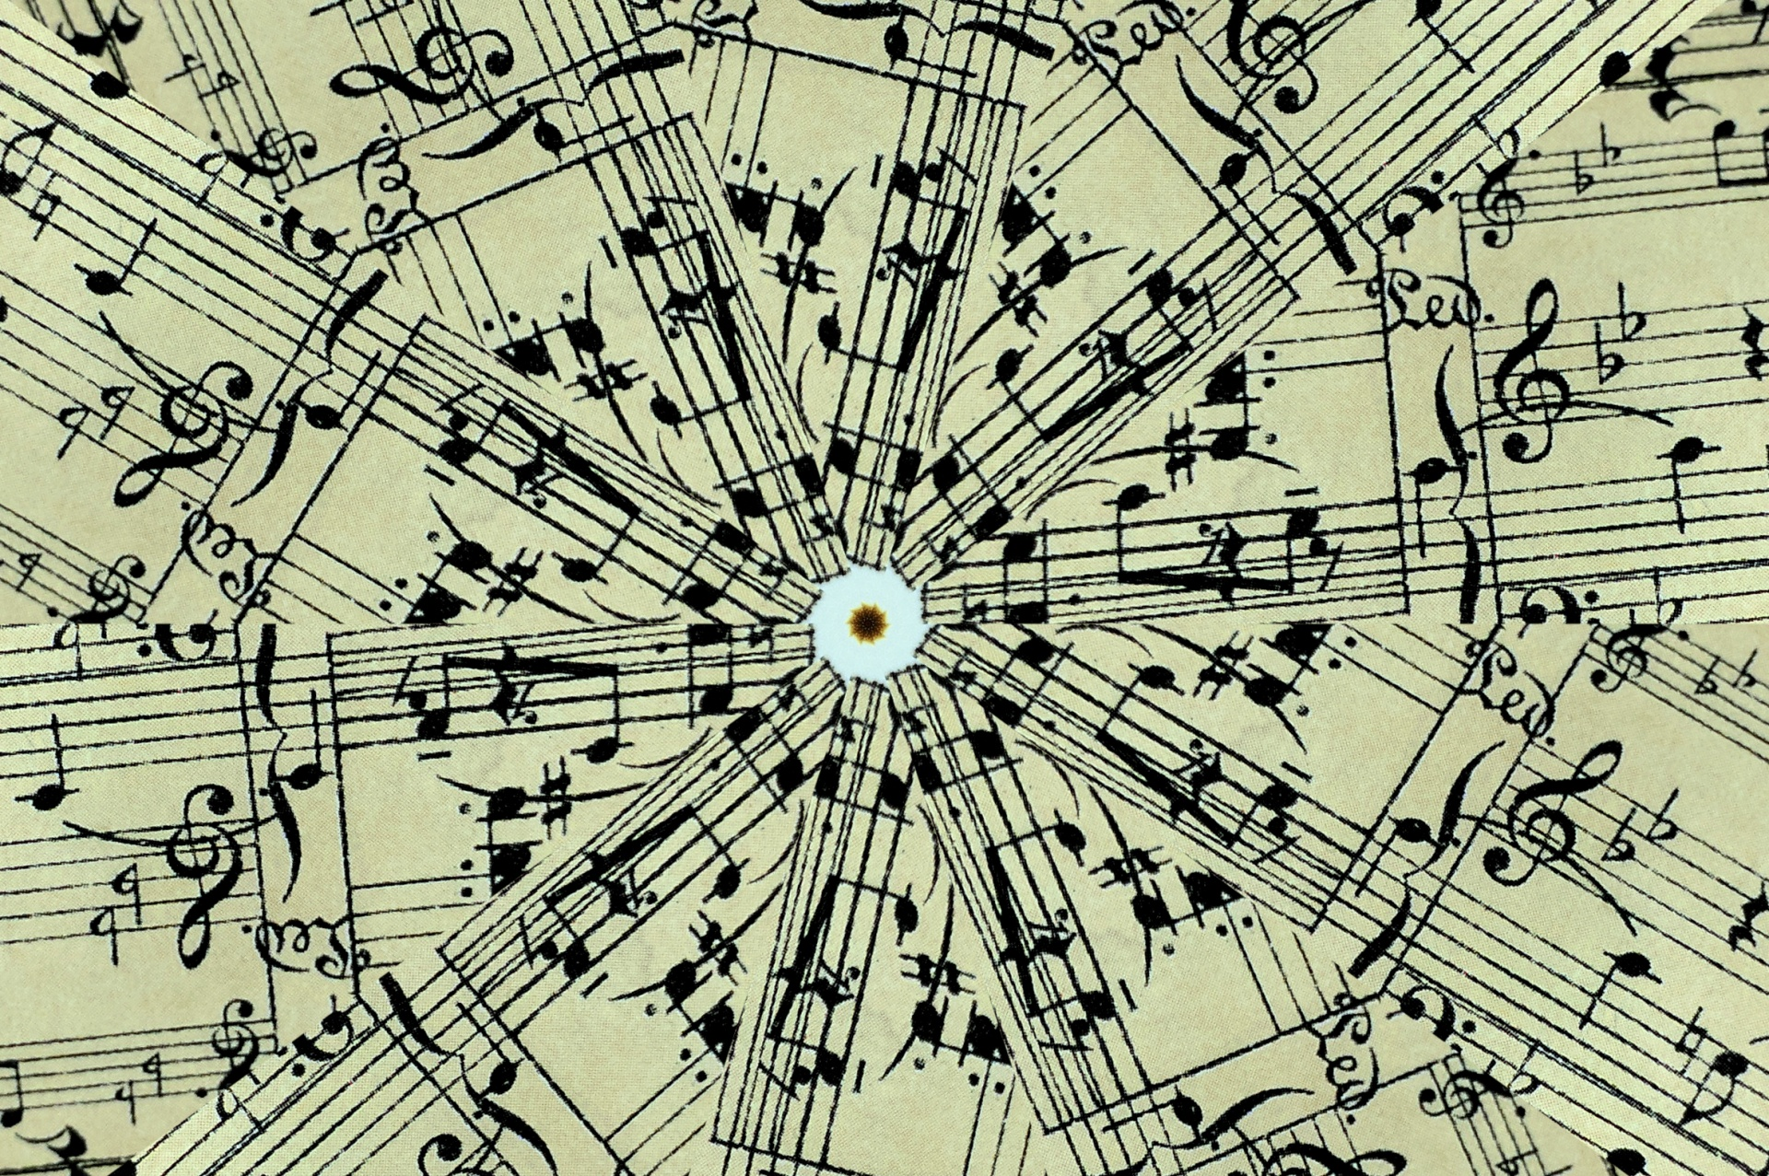

General Board Meeting

1-9-24

SIMBA



Secretary:

Facilitator:

Type of Meeting:

Timekeeper:

Location:

Time:

Meeting called by:

Date:

Zoom/Shoshana’s Office

5:30p.m. – 6:20p.m.

Shoshana Elkin - President

Shoshana Elkin - President

Shoshana Elkin - President

Jenny Warren

Mr. Taylor, Shoshana Elkins, Jenny Warren, Tina Killeen, Ashley Smith

Attendees:

\***Mr. Taylor’s Report** – picked out 2 floors to purchase for Winter Percussion, get a check for CVHS for $1500, need a truck to get floors from Phoenix by end of January. **\*Car Wash –** April fundraiser **\*BINGO Night** in Feb (Presidents Day???)– possible fundraiser coming up/set up/Jenny will schedule with Casey at 49er CC \***Pay Winter Percussion staff –** reach out to Amy Rustand **\*WGI –** paid through Boosters/going to get a refund and have Fine Arts pay for registration **\*Givebutter -** email fundraiser, hit up sponsors (Tucson Appliance, IMC), do a video with Band Kids needing a new trailer (students to head up idea) **\*Spring Trip –** packet of info out, Tax Credit is due next Monday Jan. 15 and final payment due January 30th **\*Spring Pre Festival Concert**- Feb 27 and **Spring Concert** May 16, Jazz Band Performance ASU March 27 or 28, ABODA Festival at U of A

**\*Spring Disney Trip** – do givebutter fundraiser through Booster Club, $950 cost of trip per student, subtract what was fundraised from givebutter per student, cost of trip would be $750-$800 per student, every student can pay entire trip with Tax Credit. 40 students showing interest in attending, givebutter fundraiser starting soon, full one-time payment of Spring Disney Trip due January 30, 2024 **\*Spring Bingo Fundraiser** – Jenny Warren will get in touch with Casey at 49er Country Club to set up date soon **\*Co-Chairs Next Year** – thoughts to guide new incoming parents on how SIMBA/Marching Band/Winter Band works, Feb./Mar. look for prospective parents

III. Treasurer’s Report –Amy Rustand Checking $4,385 Savings $1,661

*Savings Account -

1. Call to order 5:30 p.m.

II. Director’s Report – Mr. Taylor

IV. Mr. Taylor’s report:

**\*\*Next SIMBA meeting: Tuesday, Februray 13th @ 6:00pm on ZOOM\*\***

VI. Open Forum/VI. Schedule next meeting and Adjourn

V. Fundraising- included in Director’s Report

**AGENDA ITEMS**